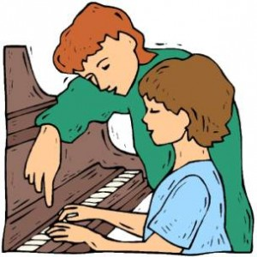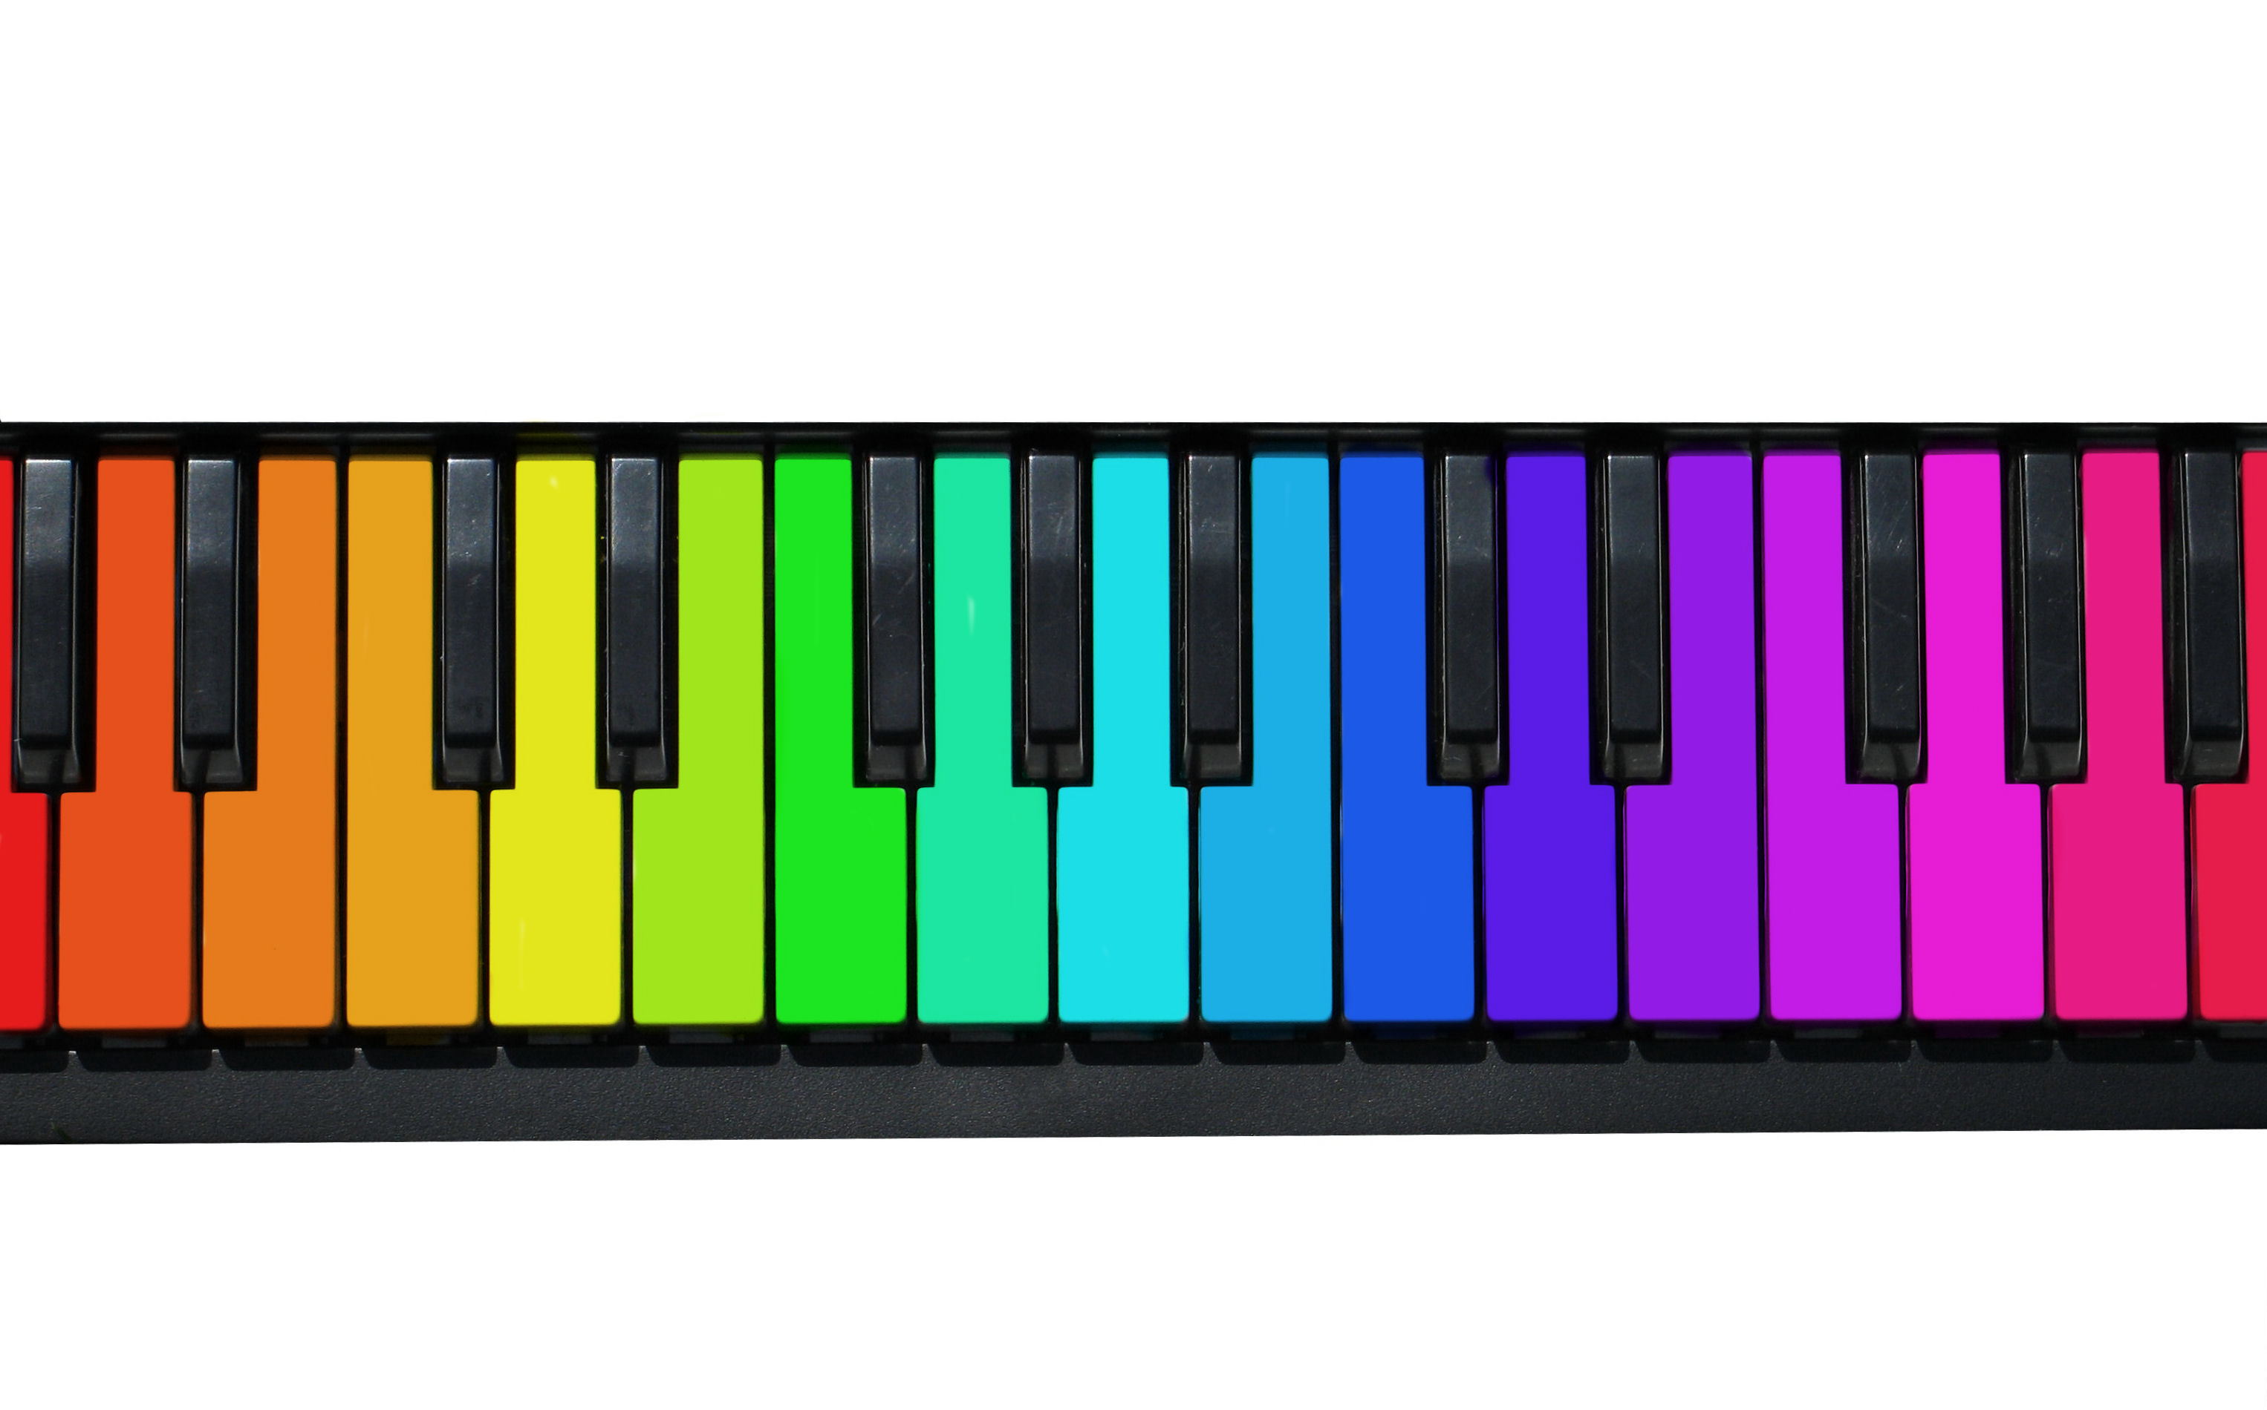

5109 49th Avenue

Box 1099

Grimshaw, AB T0H 1W0

(780) 332-2385

Janet Regal

Music Studio

Important Dates to Keep in Mind

* Canada Music Week Recital – Week of November 22nd, 2014
* North Peace Performing Arts Festival – March 15th – 27th, 2015 (Entry Deadline is Janurary 15th, 2015)
* Year End Recital – End of May 2015
* RCM Theory Examinations – Early to Mid May 2015
* RCM Practical Examinations – Early to Mid June 2015

Janet Regal has been teaching piano, organ and theory lessons in the Grimshaw/Peace River areas for over 30 years. She is the RCM Representative for the Grimshaw Centre (which is located in her home studio), a member of the Peace River & District Music Teacher’s Association, and the Alberta Music Education Foundation. She holds her RCM Grade 10 Piano, Grade 5 History and Grade 5 Harmony.

2014-2015 Music Lessons

2014-2015 Registration Form

(Detatch this Portion and Return WITH Payment)

Student’s Name:

__________________________________

Term for which you are registering:

(check all that apply)

* Fall 2014 (14 lessons) - **$245.00**
* Winter 2015 (14 lessons) - **$245.00**
* Spring 2015 (6 lessons) - **$105.00**

(Registering for all 3 terms entitles a $85 discount for a total of **$510.00**)

Parents/Guardian’s names (if under 18):

__________________________________

__________________________________

Preferred Lesson Time and Day:

__________________________________

Telephone Number (Home):

__________________________________

Email Address:

__________________________________

Signature (Parent/Guardian if under 18):

__________________________________

Date: _____________________________

Teacher’s Signature:

__________________________________

The 2014-2015 Music Lessons will be divided into 3 terms:

* Fall 2014 (Sept 8 – Dec 12, 14-*30 minute* lessons) - **$245.00**
* Winter 2015 (Jan 5 – Apr 17, 14-*30 minute* lessons) - **$245.00**

(The winter term includes one week holiday in January or February and ends the week before Easter break)

* Spring 2015 (Apr 27 – June 5, 6-*30 minute* lessons) - **$105.00**

The registration fee is based on booking a *30 minute* slot per week (for a *1 hour* slot per week multiply by 2).

Each term’s lessons must be PAID in FULL before a slot will be booked and any lessons will commence. Lesson times will be booked on a first come, first serve basis. Lessons may be paid for by cash or cheque (dated the first day of the term) for the ENTIRE amount.

Students registering for all 3 terms and paying the FULL amount at once, are entitled to a $85 discount, for a total registration fee of **$510.00**.

Additional a la carte lessons are available on a week by week basis at the rate of **$40 per hour**, and can be booked up to 2 weeks in advance.

It is the understanding of this studio that students WILL NOT schedule other commitments during their lesson time. These cancellations and no shows WILL NOT be made up. In the event of termination of this agreement, 4 weeks notice must be given of the party will be liable for the payment of the notice period.